# ATISmirus 100: The Perfect Solution for Handling Frames for Refrigerated Counter Doors

The ATISmirus 100 rigid arm manipulator is the ideal solution for optimising production and assembly processes in the commercial refrigeration sector.

Thanks to its versatility and precision, this innovative tool is indispensable for the safe and efficient handling of refrigerated counter door frames.

## Typical Applications:

* **Assembly of refrigerated counters:** Precise positioning of frames on supporting structures.
* **Handling of frames during finishing operations:** Sandblasting, painting, etc.
* **Storage and retrieval of finished frames:** Optimisation of warehouse management.

## Main Technical Features:

* **Lightweight and Flexible:** The compact and lightweight design, combined with the flexibility of the boom, allows you to operate in confined spaces and reach hard-to-reach places.
* **Column Installation on a self-standing base:** Provides exceptional stability and freedom of movement, allowing the manipulator to be positioned optimally for each operation**.**
* **Reach 4000 mm:** Covers a large working area, facilitating the handling of frames within production lines.
* **Load capacity 80 kg:** Perfect for handling the typical loads of refrigerated counter door frames, while ensuring high precision.
* **Gripping System with Adjustable Forks:** Designed specifically to adapt to different frame sizes and shapes, ensuring a secure and stable grip.

**Increased Productivity:** Reducing cycle times and minimising manual errors.

**Improving Security:** Elimination of the risk of accidents related to the manual handling of heavy loads.

**Greater Accuracy:** Positioning of frames with maximum precision, ensuring perfect assembly.

**Versatility:** Adaptable to different types of frames and production line configurations.

**Durability:** Made of high-quality materials and designed to withstand the wear and tear and stresses typical of the industrial environment.

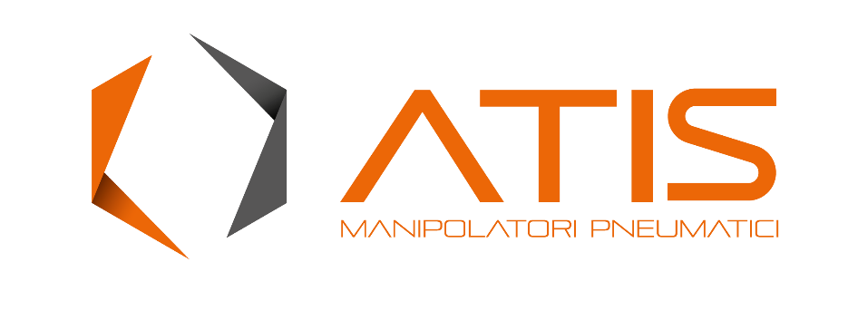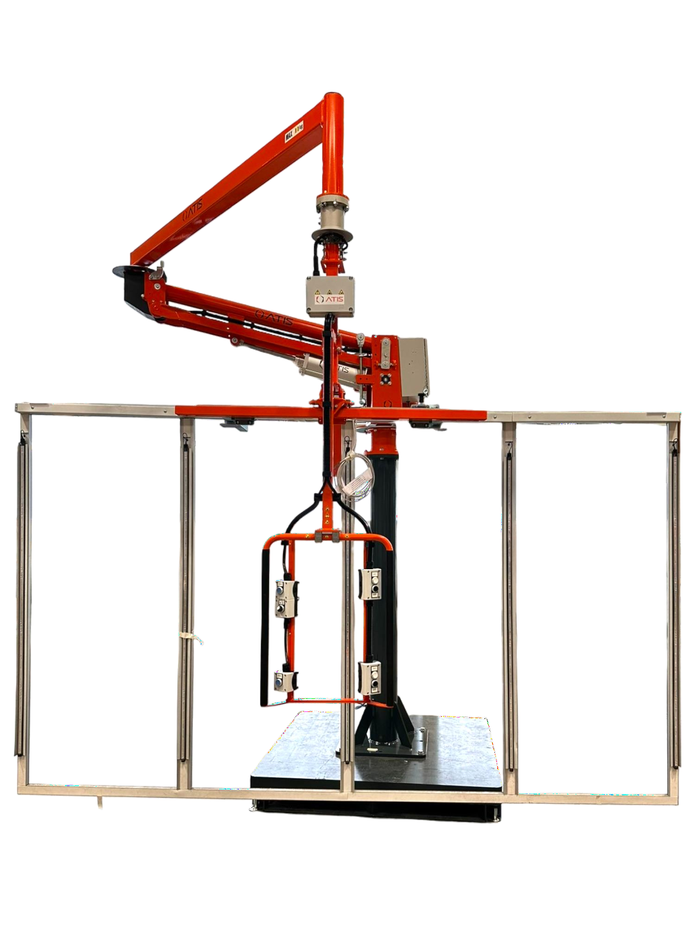

# Optimise your production with the ATISmirus 100 manipulator!

The ATISmirus 100 is the ideal solution for companies wishing to improve the efficiency and safety of their production processes in the commercial refrigeration sector. Thanks to its versatility and high performance, this manipulator is a safe investment for the future of your business

# [www.atismanipolatori.com](http://www.atismanipolatori.com/) – [atis@atismanipolatori.com](mailto:atis@atismanipolatori.com)

**ATIS srl** I 38017 Mezzolombardo (TN) -I- I Via Tren[to, 112-114 I T. +39 0461 662031 ra I a](http://www.atismanipolatori.com/)[tis@atismanipolatori.com](mailto:atis@atismanipolatori.com)